**Zhumagali Kanat IT2-2003**

**Practice 6**

1. Create, compile, and invoke the ADD_JOB procedure and review the results.

* + - 1. Create a procedure called ADD_JOB to insert a new job into the JOBS table. Provide the ID and job title using two parameters.
      2. Compile the code, and then invoke the procedure with IT_DBA as the job ID and Database Administrator as the job title. Query the JOBS table and view the results.
      3. Invoke your procedure again, passing a job ID of ST_MAN and a job title of Stock Manager. What happens and why?

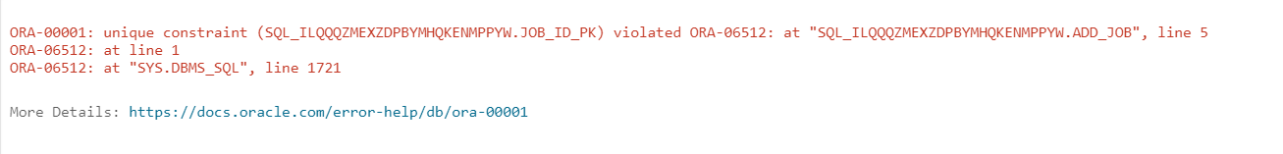

create procedure add_job(

j_id in jobs.job_id%type,

j_title in jobs.job_title%type) is

begin

insert into jobs(job_id, job_title) values (j_id,j_title);

end add_job;

execute add_job('IT_DBA', 'Database Administrator')

execute add_job('ST_MAN', 'Stock Manager')

select * from jobs

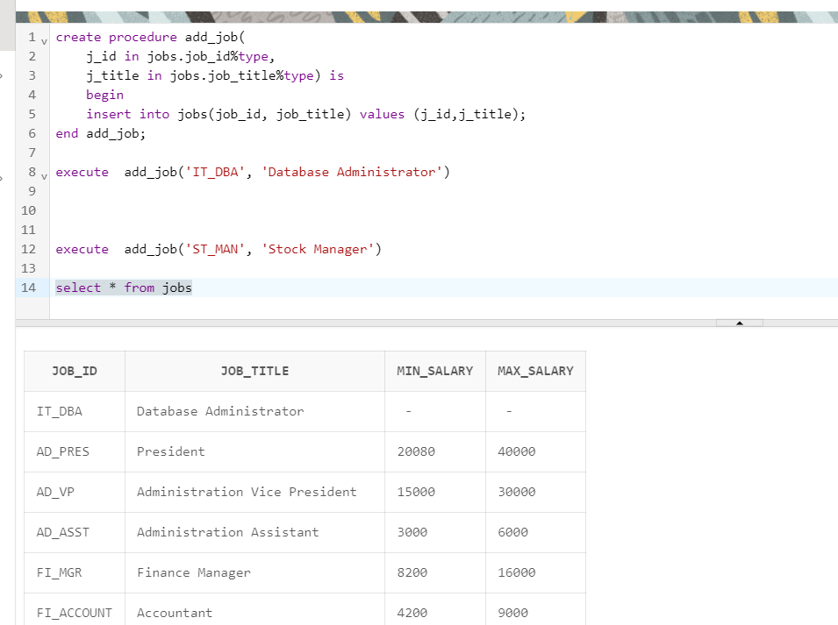

2. Create a procedure called UPD_JOB to modify a job in the JOBS table.

* + - 1. Create a procedure called UPD_JOB to update the job title. Provide the job ID and a new title using two parameters. Include the necessary exception handling if no update occurs.
      2. Compile the procedure. Invoke the procedure to change the job title of the job ID IT_DBA to Data Administrator. Query the JOBS table and view the results.
      3. Test the exception handling section of the procedure by trying to update a job that does not exist. You can use the job ID IT_WEB and the job title Web Master.

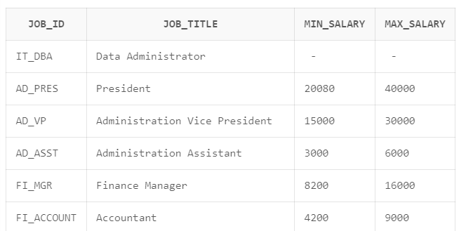

create or replace procedure upd_job(

j_id jobs.job_id%type,

j_ntitle jobs.job_title%type) is

begin

update jobs set job_title = j_ntitle where job_id = j_id;

if(sql%rowcount = 0) then dbms_output.put_line ('No data found for updating...');

else dbms_output.put_line('Nice! ');

end if;

exception when others then dbms_output.put_line('error');

end upd_job;

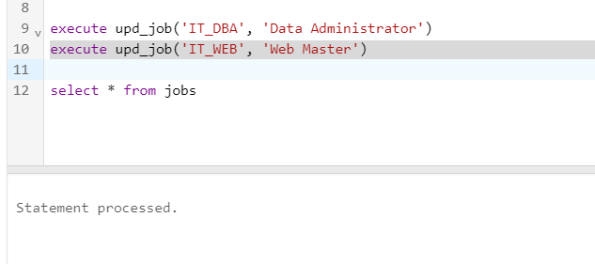

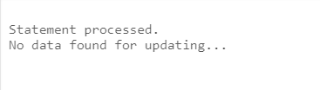

3. Create a procedure called DEL_JOB to delete a job from the JOBS table.

* + - 1. Create a procedure called DEL_JOB to delete a job. Include the necessary exception handling code if no job is deleted.
      2. Compile the code; invoke the procedure using the job ID IT_DBA. Query the JOBS table and view the results.
      3. Test the exception handling section of the procedure by trying to delete a job that does not exist. Use the IT_WEB as the job ID. You should get the message that you included in the exception handling section of the procedure as the output.

create or replace procedure del_job(

j_id jobs.job_id%type

) is

begin

delete from jobs where job_id = j_id;

if(sql%rowcount = 0) then dbms_output.put_line ('No data found for deleting...');

else dbms_output.put_line('Nice! ');

end if;

exception

when others then dbms_output.put_line('error');

end del_job;

execute del_job('IT_DBA')

execute del_job('IT_WEB')

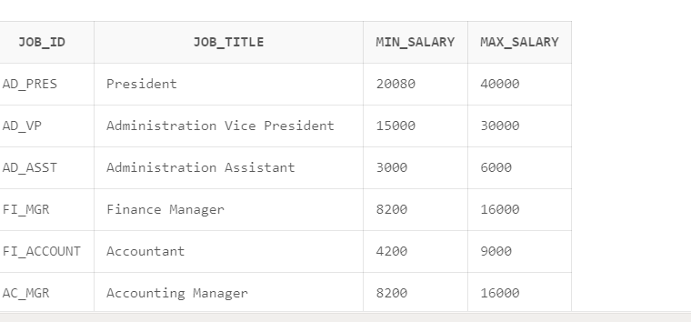 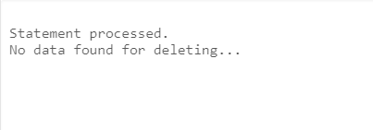

4. Create a procedure called GET_EMPLOYEE to query the EMPLOYEES table, retrieving the salary and job ID for an employee when provided with the employee ID.

a. Create a procedure that returns a value from the SALARY and JOB_ID columns for a specified employee ID. Compile the code and remove syntax errors, if any.

b. Create an anonymous block and call the procedure using variables for the two OUT parameters – one for the salary and the other for the job ID. Display the salary and job ID for employee ID 120.

c. Invoke the procedure again, passing an EMPLOYEE_ID of 300. What happens and why?

create or replace procedure get_employee (

e_id in employees.employee_id%type,

j_id out employees.job_id%type,

salary out employees.salary%type

) is

begin

select salary, job_id into salary, j_id from employees where employee_id = e_id;

exception

when no_data_found then dbms_output.put_line('No data found for this id');

when others then dbms_output.put_line('Error');

end get_employee;

declare

emp_job employees.job_id%type;

emp_sal employees.salary%type;

begin

get_employee(120, emp_job, emp_sal);

dbms_output.put_line('Job ID: ' || emp_job || ' Salary: ' || emp_sal);

end;

